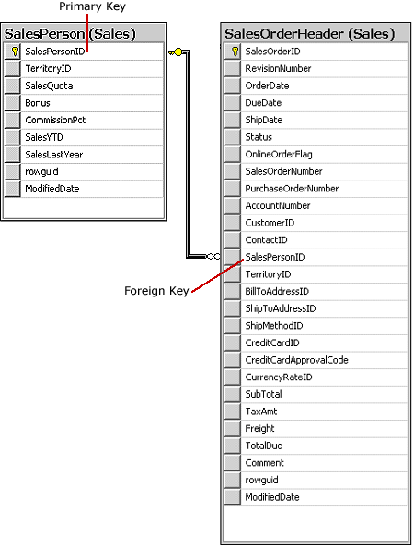

A FOREIGN KEY constraint does not have to be linked only to a PRIMARY KEY constraint in another table; it can also be defined to reference the columns of a UNIQUE constraint in another table. A FOREIGN KEY constraint can contain null values; however, if any column of a composite FOREIGN KEY constraint contains null values, verification of all values that make up the FOREIGN KEY constraint is skipped. To make sure that all values of a composite FOREIGN KEY constraint are verified, specify NOT NULL on all the participating columns.